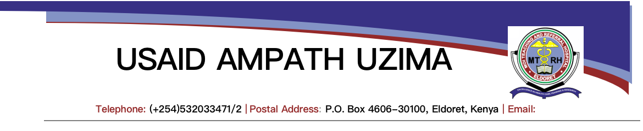

|  |  |
| --- | --- |
| **STANDARD OPERATING PROCEDURE FOR HANDLING EMANCIPATED MINORS** | |
| Version Number: | 07.2022 |
| Effective Date: | Next revision date: |
| Signed by COP |  |

**Definition of Terms**

The following key terms used in this document are defined in the context of their usage when handling emancipated minors to ensure a common and shared understanding for the interpretation of the SOP.

* **Access to services -**Access to services encompasses preventative efforts such as family planning and in the case of HIV and AIDS, includes counselling and testing
* **Emancipation of minors –** An emancipated minor refers to any person below the age of 18 years who is considered freed from control by their parents or caregivers, and the parents or caregivers are freed from responsibility for their child. Emancipated minors are allowed to legally make certain decisions on their own behalf.

Emancipated minors include any individual below 18 years of age who is:

1. Married/Living with intimate partner
2. Pregnant
3. A mother
4. Economically self-dependent
5. Has lived independent of parental guidance for a minimum of one (1) year
6. Is engaged in risky behavior putting them at risk of contracting HIV
7. Is living in the street
8. Is the head of household

* **A minor** - Any person below the age of 18 years. This excludes emancipated minors.
* **Assent** -Assent is an affirmative agreement of a child (aged 12-17 years). It is used to define the role for an adolescent that lies between non-involvement and full decisional authority to participate in or access to services
* ***Assent/Dissent Required***-Assent/dissent is the requirement, for children without the capacity to provide informed consent, of engaging a child so that they understand, appreciate, and can give an opinion on accepting/rejecting decisions that are being made for them. Guidelines in the Kenya health sector are largely silent on the requirement for child assent

**Services where documentation of emancipation is required**

1. HIV services-HTS for those aged below 15 years, linkage to care, care and treatment, HIV prevention services SRH services- contraceptive services, post abortal care services
2. STI screening and treatment
3. Mental health and substance abuse services- screening and intervention services
4. Immunizations
5. Prenatal care

**N/B**

Adolescents 15-18 years do not need documentation of emancipation for assenting for HIV testing services. The Kenya HTS guide requires only a verbal assent.

**Services where documentation of emancipation is not accepted and are exempted from this SOP**

1. Suspected or documented emotional, physical, or sexual abuse
2. Underage sexual activity
3. Unconsented or coerced use of HIV self-testing technologies
4. Child abuse and neglect due to withholding of medical or social services
5. Required reporting of infectious diseases
6. Research
7. Exposure risk and treatment for providers in occupational settings
8. Emergency diagnosis and medical care or social support
9. Criminal/legal liability

**Handling Emancipated Minor Process Flow chart**

Explore the emancipation status and document in patient file

Discuss need for parent/caregiver/ other supportive adult involvement when the child is ready- best interest of child

Explain the content of the service to be provided and the assent to the child so that they understand, appreciate, and can give an opinion on accepting/rejecting decisions that are being made for them.

Ask the minor whether they assent to the decisions that are being made for them

Minor gives assent- yes, Document assent in patient file

Minor does not assent-Document, end session, communicate on availability of service when ready

END

Have a witness sign (SW/DCS/Legal officer/Doctor/ clinical officer/Nurse

Request minor to sign or thumbprint and date two copies of the assent form

Keep the original assent form and documentation of service offered in the patient file

Offer service or procedure assented to the minor and document the same